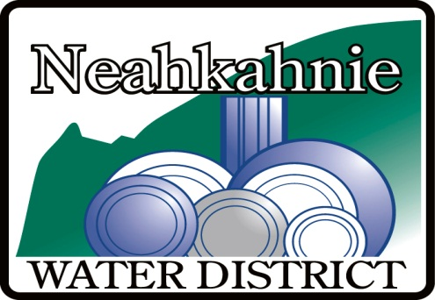

**NEAH KAH NIE WATER DISTRICT**

**ADVISORY COMMITTEE MEETING**

**FRIDAY, AUGUST 22, 2025**

**2:30 PM VIA VIDEO CONFERENCE & IN PERSON AT THE OFFICE**

**(Ph: 503-368-7309 for instructions)**

**9155 NEHALEM ROAD in NEAH KAH NIE BEACH**

**AGENDA**

* **CALL TO ORDER –** Date,start time, and who is in attendance.
* **PUBLIC MEETING under ORS 192.630**

The Committee is composed of Neahkanie community members that will advise the Board on matters related to water storage infrastructure.  Members are: Craig Nern, David Boone, Pam Greene, Mike Woodin, Andrew Beyer, Stuart Jones, John Bloom, and Marc Johnson.

* Scope of Committee activity
* Discussion of current infrastructure
* Outline of possible strategies related to growth and firefighting reserves
* Discussion of tank locations, materials and costs

.

* **PUBLIC COMMENT**

* **ADJOURNMENT**